  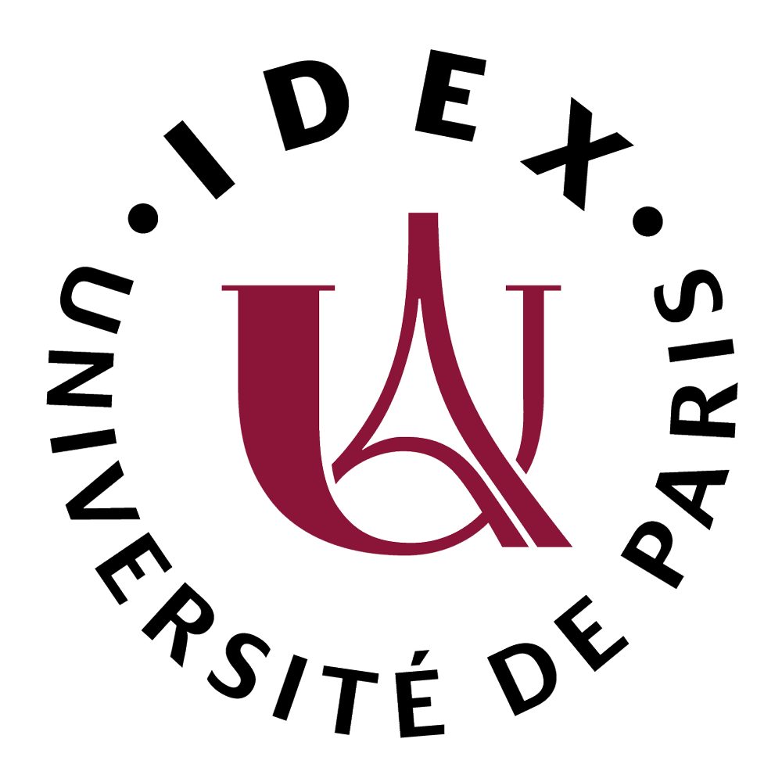



**International Scientific Conference**

**SPECIALISED LANGUAGE TEACHING IN THE ERA OF GLOBALISATION**

**7-8 October 2021**

**The conference will be held in a hybrid format**

**in cooperation with the Scientific Station of the Polish Academy of Sciences in Paris**

**and Global Research Institute of Paris (Paris University)**

Integration processes, rapid flow of information, dizzying technological advances, intensive development of multinational corporations, free movement of people, hybrid social practices, and so on, are complex processes occurring on a global scale, and are indicative of increasing globalisation (Sassen 2009). The combination of these global trends and their local conditions has not yet been the subject of much consideration in the context of foreign language teaching. It is worth recalling that such issues accompanied the proceedings of the FIPF conference held in 2014, which was also reflected in the post-conference publication (edited by Babault et al. 2014), and in particular in several texts discussing theoretical issues concerning scales and norms (Castellotti, Hurver, Narcy-Combes) and highlighting the need for greater diversity of outlooks and methods in the field of language teaching. It must be stressed, however, that the works cited did not refer to professional/specialist learners, but to foreign language teaching in general.

Therefore, it seems all the more justified to mention selected aspects of the above mentioned issues in the context of specialist language teaching. Recently, teachers dealing with the teaching of foreign languages for professional purposes have joined ranks through a number of international conferences, which were devoted, among others, to the competences of specialist language teachers (Lublin 2018; Sowa 2020) or issues of language education for the labour market (Lyon 3 2015). So far, there are still few meetings and scientific works that reflect on the problem of creating language courses and classes in a global context. A consequence of this is that quite often the belief still persists that the ways of speaking, writing, negotiating are identical in every field communicating using the same language.

While the forms of action in one or another field may be more or less universal, communicative practices are not always and everywhere identical. This is because discursive genres form a certain ritualised 'collective style' that favours and treats as legitimate certain formulations and modes of exchange found in a given language and culture. This also applies to communities whose communicative practices are relatively homogeneous (e.g. tourism), and which Beacco (1992: 15) calls 'communautés de communication translangagières'. Revisiting this notion is not pointless, as it is closely related to what is relevant in a time of globalisation. According to Beacco, translingual communicative communities are those which have a strong foothold in a particular institution (a multinational company, an international organisation, a scientific or academic field, a worldwide professional industry), where the status of the participants in communication is established, the circulation of writings can be described, but which function in more than one natural language. The globalisation of economic and cultural exchange has obviously developed such international and multilingual institutions. There is, thus, a need to reactivate this notion of a translingual communicative community, and this in turn entails the legitimacy of seeking answers to the question of common standards and variability of language use in the domain areas of interest to language educators and teachers.

The last 20 years have also seen the emergence of other issues that have been bothering language teachers more than ever before. It is now possible to identify around ten so-called languages of international communication (Cerquiglini 2019), which are often used for communication in areas geographically very distant from their 'birth' place. This situation raises a number of questions regarding the teaching of specialised languages. How do we define a specialised language? What kind of communicative practices should we relate it to? Which of these practices should be regarded as the most representative: those of the cradle country of a given language, those of emerging countries with dynamic demographics where the number of speakers of a given language is growing, or those of countries with strong economic expansion in languages other than their own? Is it still possible to speak of a specialist language in the singular in a global world? Beyond local lexical and phonological differences, is there a single universal Business English, *français de la mode* or *français médical* at the level of discourse and communication?

**Thematic areas**

Accordingly, we invite those interested in the above-described topics to reflect on how specialised languages are defined at the conceptual, linguistic and teaching levels in the age of globalisation. We propose the following thematic areas:

**Area 1.** The problematic circulation of key concepts in the teaching of specialised languages, which operate in different languages and which are used by researchers/teachers in the era of the Citation Index and the internationalisation of research. In particular, we bear in mind the registers of professional communication developed in German (Efing 2014; Roelcke 2018) and defined by *Fachsprache, Arbeitssprache, Berufssprache*..., among others, which do not always find their counterpart in other languages/education systems, and even if they exist, are not always part of such a continuum. In French, the specialised languages long identified with the term *Français de spécialité* are also evolving, entering the intervention areas of French for Specific Purposes (*Français sur Objectif Spécifique*), French as a Professional Language (*Français Langue Professionnelle*) and French as a Language of Integration (*Français Langue d'Intégration*), and so on. In English, for a long time, the reflection on the teaching of English for Specific Purposes differentiated Professional English, Vocational English, English for Occupational Purposes, and so on, which gradually seems to be disappearing (English for Careers, English in Use). The issues highlighted above raise questions about the potential 'transferability' of similar terms and their possible transposition internationally.

**Area 2:** Conversational and editorial principles to be taught in an era when some languages (such as English or French) have a global reach and are used in specialist/professional transactions across continents between interlocutors speaking different variants of a given language (Arabic English, Chinese English, Hong Kong English, etc.). It is important to note the 'deterritorialisation' of specialised languages observable in places such as conference centres, airports, which Agier (2015) refers to as 'non-places'. This deterritorialisation is more pronounced today through the massive use of virtual spaces (video conferencing, blogs). Also, many specialist interactions do not necessarily pass through the European continent, that used to serve as a model. As an illustration, let us take an example from the field of tourism: a cruise ship in the Mediterranean, with French-speaking passengers from Belgium, Switzerland, France or even Quebec, is manned by crew members who come from the Maghreb or who have in the past practised as French-speaking guides in their country (e.g. Romania, Croatia), and native French speakers are in the minority, even when the ship sails along the coast of Sicily.

**Area 3:** New ways of teaching specialised languages in a globalised world. How and to what extent do classroom practices, teaching aids, language resources, and so on, reflect the diversity in the use of specialised languages taught for professional communication? How can the global dimension and context of specialised language use be taken into account in language teacher education?

**References:**

Agier, M., 2015, *Anthropologie de la ville*, Presses Universitaires de France, « Hors collection ».

Ammon, U., 2010, *World languages; Trends and futures,* in Coupland, N. ed., *The Handbook of Language and Globalization,* Wiley-Blackwell, pp. 101-122.

Babault, S., Bento, M., Le Ferrec, L. et Spaëth, V., 2014, *Contexte global, contextes locaux. Tensions, convergences et enjeux en didactique des langues*, Actes de colloque international, FIPF, <https://halshs.archives-ouvertes.fr/halshs-01044944>.

Beacco, J.-C., 1992, Les genres textuels dans l’analyse du discours : écriture légitime et communautés translangagières, *Langages* 105 *Ethnolinguistique de l’écrit,* Larousse, pp. 8-27.

Cerquiglini, B., 2019, « La francophonie vue par B. Cerquiglini. La vigueur d’une langue-monde » in *La langue française dans le monde,* Gallimard et OIF, p. 22-23.

Desjeux, D., 2002, Les échelles d’observation de la culture, *Communication et organisation* 22, mis en ligne le 27 mars 2012, consulté le 01 mai 2019. [En ligne]. URL : http://journals.openedition.org/communicationorganisation/.

Efing, C., 2014, Berufssprache and Co. Berufsrelevante Register in der Fremdsprache. Ein varietätenlinguistischer Zugang zum berufsbezogenen DaF-Unterricht, *Informationen Deutsch als Fremdsprache* 41, pp. 415-441.

Paltridge, B., Starfiedl, S., 2012, *The Handbook of English for Specific Purposes,* Wiley-Blackwell.

Roelcke, T., 2020, Berufssprache und Berufliche Kommunikation – eine konzeptionnelle Klärung, in *Sprache im Beruf,* Band 3 – Heft 1, Steiner Verlag, pp. 3-17.

Sassen, S., 2009, *La globalisation. Une sociologie,* NRF Gallimard.

Sowa, M. dir., 2020, *In search of the LSP teacher’s competencies/ A la recherche des compétences des enseignants de LS*, Peter Lang.

Van der Yeught, M., 2016, Protocole de description des langues de spécialité, in *Les Cahiers de l’APLIUT,* vol. 35/1, numéro spécial *Du secteur LANSAD et des langues de spécialité,* URL : [http://journals.openedition.org/apliut/5549](http://journals.openedition.org/apliut/5549 ); DOI : <https://doi.org/10.4000/apliut.5549>

**Rules for submission of papers:**

Submissions with proposed paper titles together with abstracts (300 words) should be sent to: **lsp.globalisation@gmail.com** by **30 June 2021**. The submission should also include the speaker's name, affiliation and email address.

Paper proposals may be formulated in **English** or **French**.

Acceptance/rejection of the paper will be communicated by 3 July 2021.

The conference will be held **in a hybrid format**. **Participation** in the conference **is free of** **charge**.

Participation must be confirmed by registering via the online form by 30 September 2021 at the latest.

Papers accepted for presentation, after receiving two positive reviews by two independent reviewers, will appear in a monograph published by Peter Lang Publishing.

**Organising Committee**

* Florence Mourlhon-Dallies, GRIP, Université de Paris, France
* Magdalena Sowa, Maria Curie-Skłodowska University, Lublin, Poland
* Joanna Kic-Drgas, Adam Mickiewicz University, Poznań, Poland

**International Scientific Committee**

Hervé Adami, Université de Lorraine, Nancy, France

Virginie André, Université de Lorraine, Nancy, France

Christian Efing, Aachen University, Germany

Elżbieta Gajewska, University of Pedagogy, Cracow, Poland

Sambor Grucza, University of Warsaw, Poland

Jarosław Krajka, Maria Curie-Skłodowska University, Lublin, Poland

Isabelle Léglise, SeDyl CNRS, Fédération F3S et GRIP, Villejuif and Paris, France

Jean-Marc Mangiante, Université d’Artois, Arras, France

Chantal Parpette, Université Lumière-Lyon 2, France

Jean-Jacques Richer, Université de Bourgogne, Dijon, France

Cédric Sarré, Sorbonne Université, Paris, France

Séverine Wozniak, Université Grenoble-Alpes, France